

|  |
| --- |
| Lu Chunqiu |
| RIP Project |
| Introduction |
|  |

|  |
| --- |
| Information Technology |
| 2013 |

RIP project is the project of Information Technology Department Nov.2012 to March.2013 project course. It creates power line remote monitor and control system. Figure 1 demonstrates the overall diagram of this project. It can

* Read the three-phase current value of three remote power lines separately
* Control the breaker of three remote power lines separately
* break the power lines automatically by VAMP relay when overcurrent happens

It consists of

|  |  |
| --- | --- |
| **Name** | **Description** |
| MicroSCADA | Remote monitor and control the power line |
| Radio modem | Connecting microSCADA to RTU |
| IEC 60870-5-101 | Protocol between microSCADA and RTU |
| Modbus RTU | Protocol between RTU and relays |
| RTU | Convert the IEC-60870-5-101 frame from controlling station to Modbus RTU frame and convert the returning Modbus frame back to IEC101 frame |
| Three VAMP relays | Locally monitor and control the power line |
| SIM600 | Simulate the power line environment |

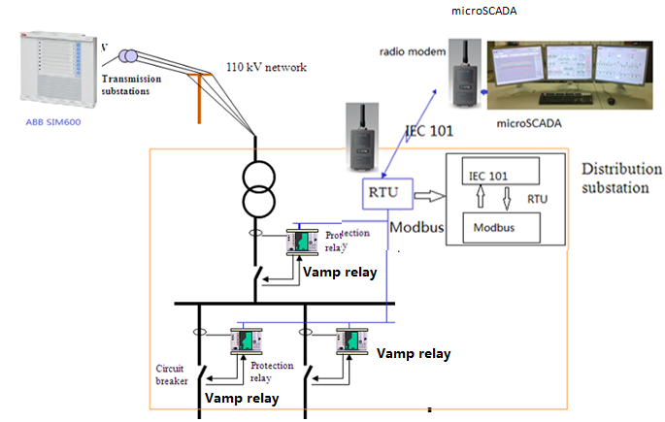

Figure 1. RIP overall diagram

For more detail information, please refer to the manual separately.

Team member

Supervisor: Jukka Matila

Student member:

|  |  |
| --- | --- |
| **Group Name** | **Group member** |
| MicroSCADA | Juri Fredlund |
| Juhana Tuomisto |
| Protocol | Lu Chunqiu |
| Li Jinpeng |
| He Shilei |
| Relay | Ville Kurhela |
| Tanveer Altaf |
| SIM600 | Joakim Mattson |
| Marek Krajewski |
| RTU | Lu Chunqiu |
| Marek Krajewski |
| Juri Fredlund |
| Others | Lu Chunqiu |
| Li Jinpeng |